**ASSIGNMENT-2**

**IAM Policies**

**Done By**

**RANJITH KUMAR**

**Tasks To Be Performed:**

1. Create policy number 1 which lets the users to:

a. Access S3 completely

b. Only create EC2 instances

c. Full access to RDS

2. Create a policy number 2 which allows the users to:

a. Access CloudWatch and billing completely

b. Can only list EC2 and S3 resources

3. Attach policy number 1 to the Dev Team from task 1

4. Attach policy number 2 to Ops Team from task 1

**TASK 1:**

1. Create policy number 1 which lets the users to:

a. Access S3 completely

b. Only create EC2 instances

c. Full access to RDS

**STEP 1 :** Open **IAM** in aws services

**STEP 2 :** In the Access management select **Policies**

**STEP 3:** In policies window select **create policy**

**STEP 4**: In select a service select “**S3**”

**STEP 5 :** Select All S3 actions & In Resources select ALL

**STEP 5 :** Select add more permissions and select “**RDS**”

**STEP 6 :** Select All RDS actions & In Resources select ALL

**STEP 7 :** Select add more permissions and select “**EC2**”

**STEP 8 :** Select Create & Describe tags , create & describe image ,

Describe instance & instance type & run instance , Describe & create

Keypair , Descrive VPC , Describe subnets , Describe security group & rules , Create attach describe volume , Create attach describe network interfaces to only create a instances.

**STEP 9 :** Click next

**STEP 10 :** Give name to the policy in review and create page

**STEP 11 :** Policynumber_1 has been created

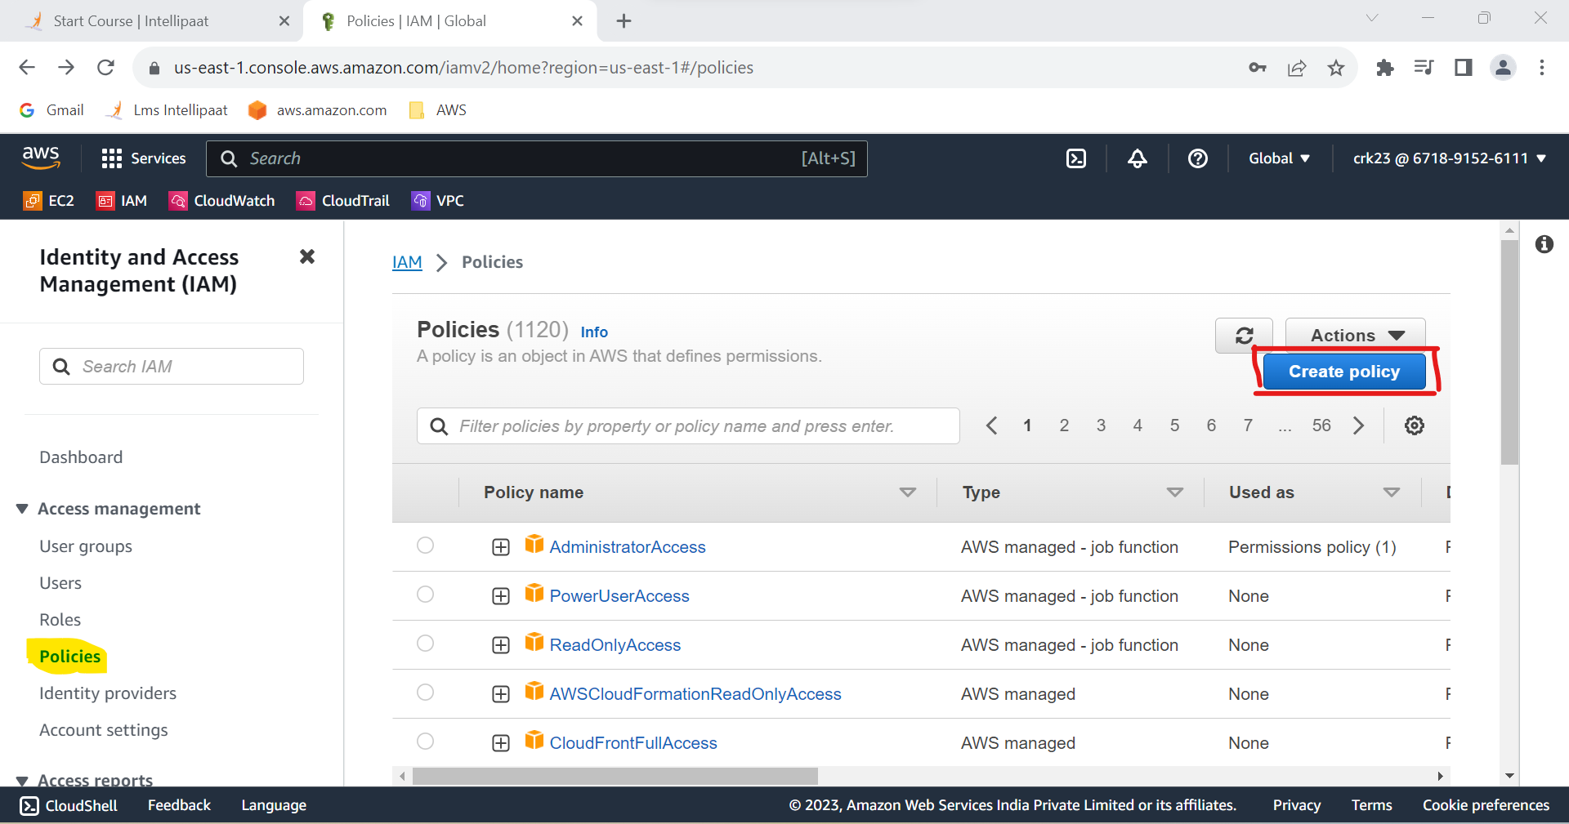

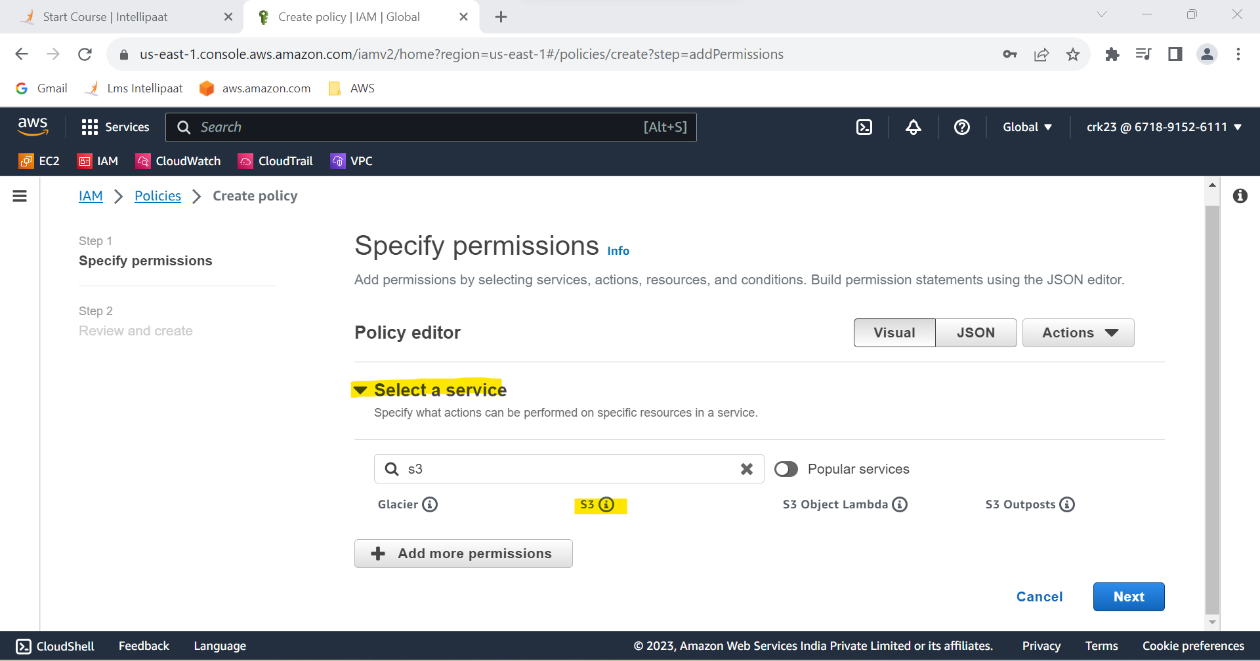

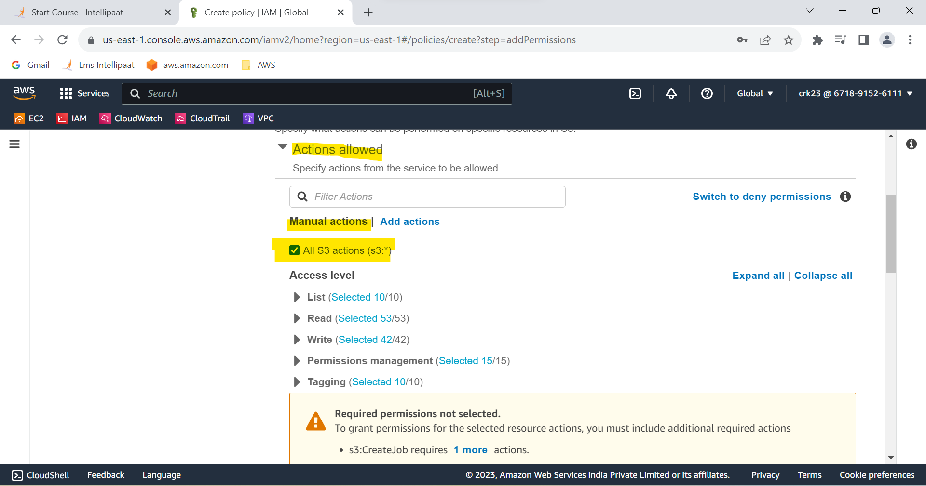

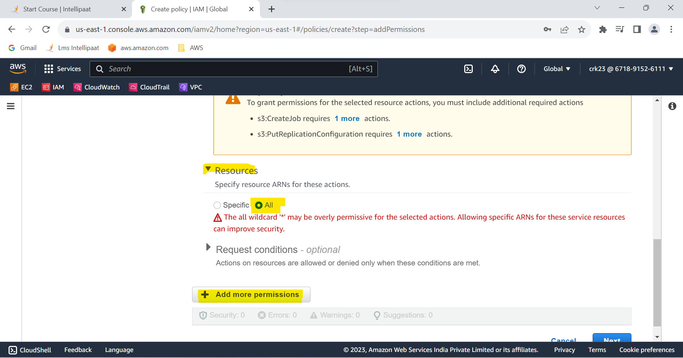

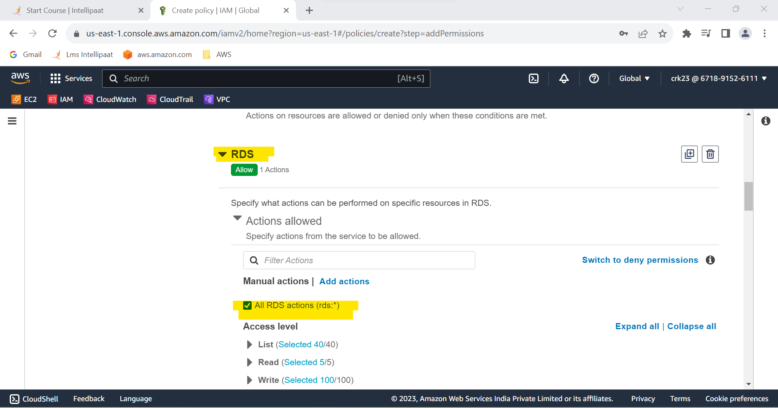

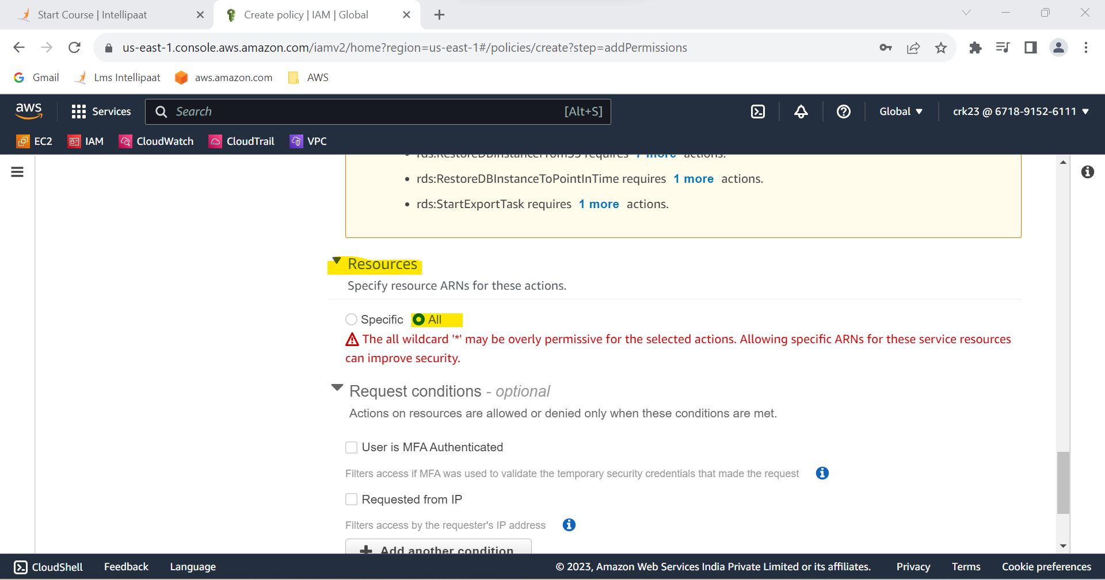

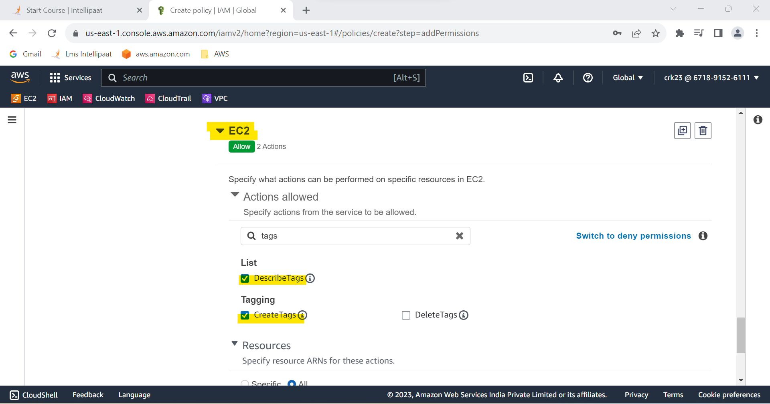

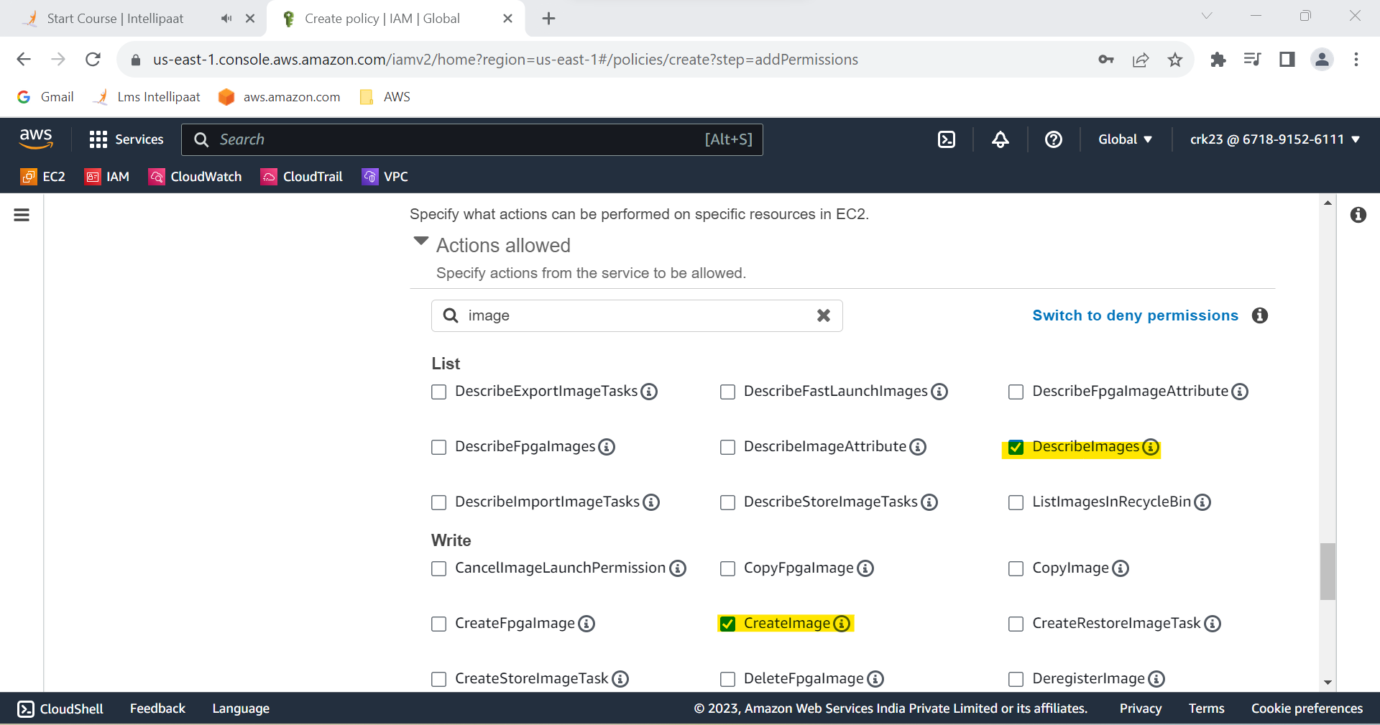

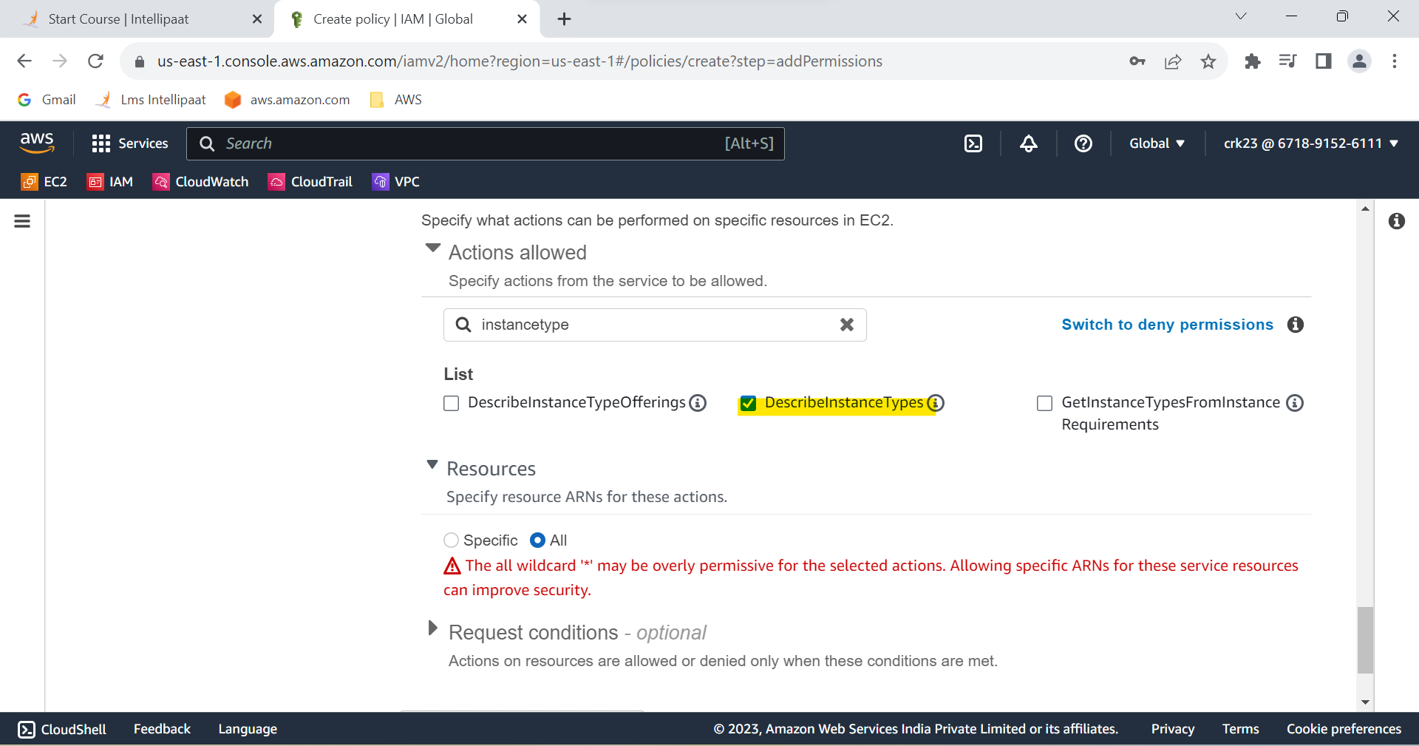

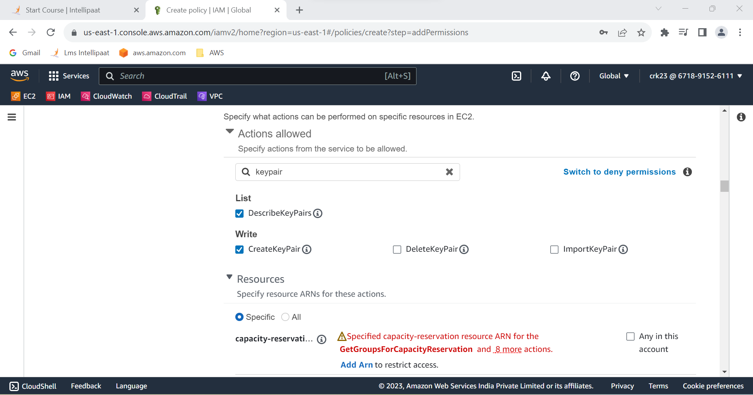

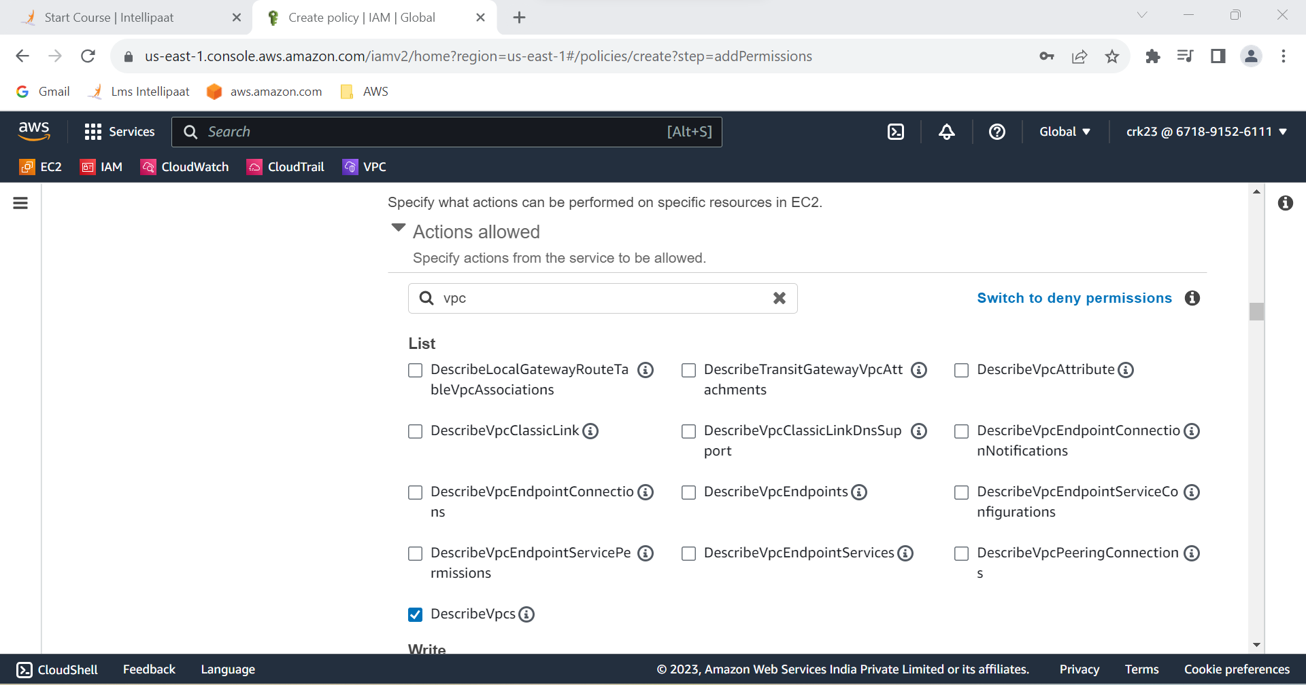

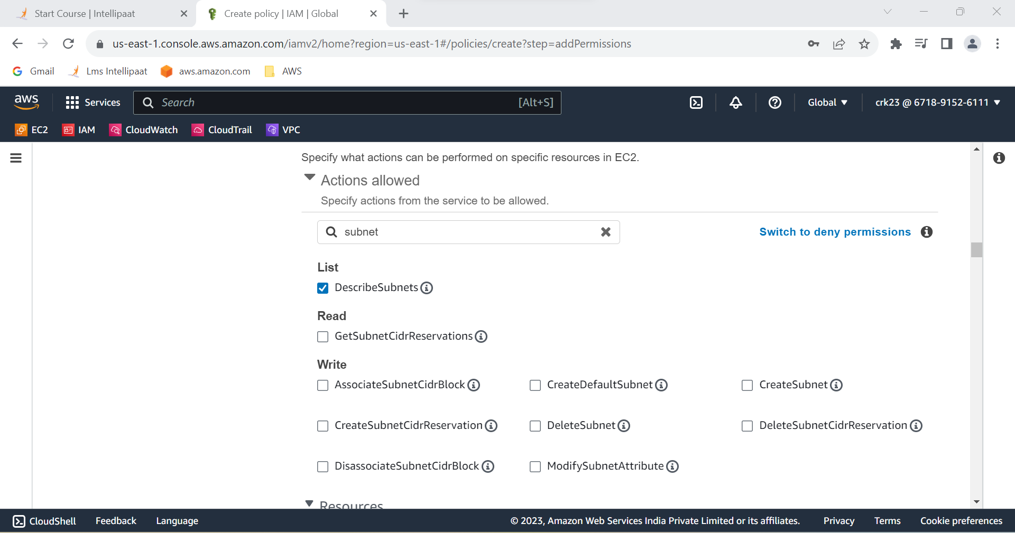

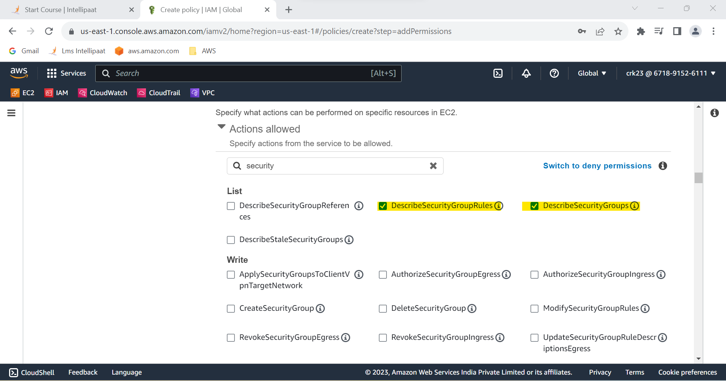

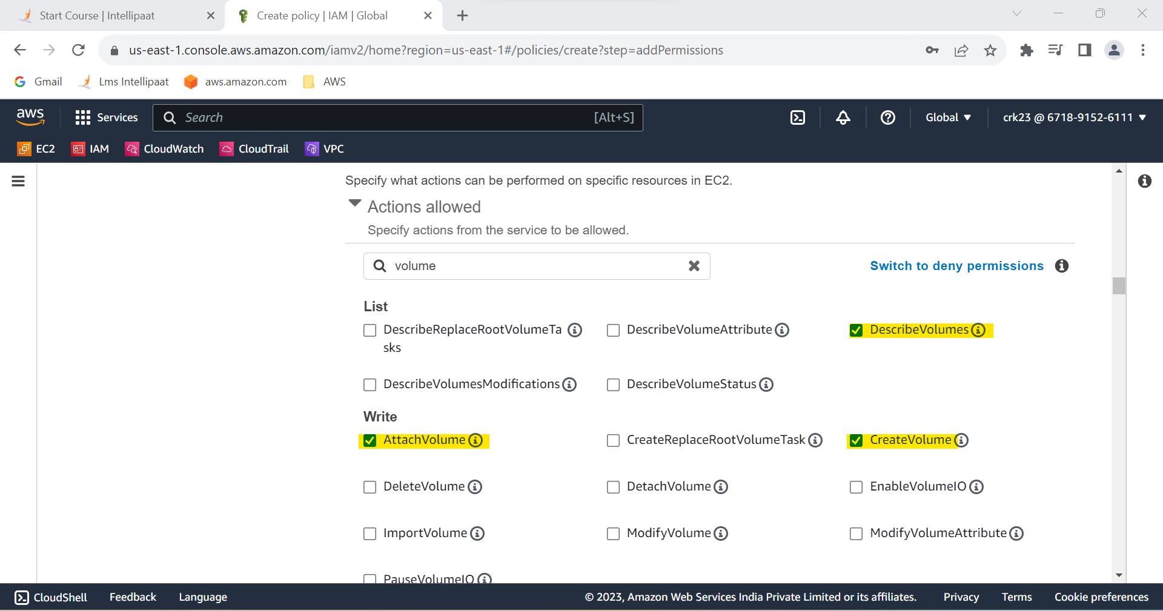

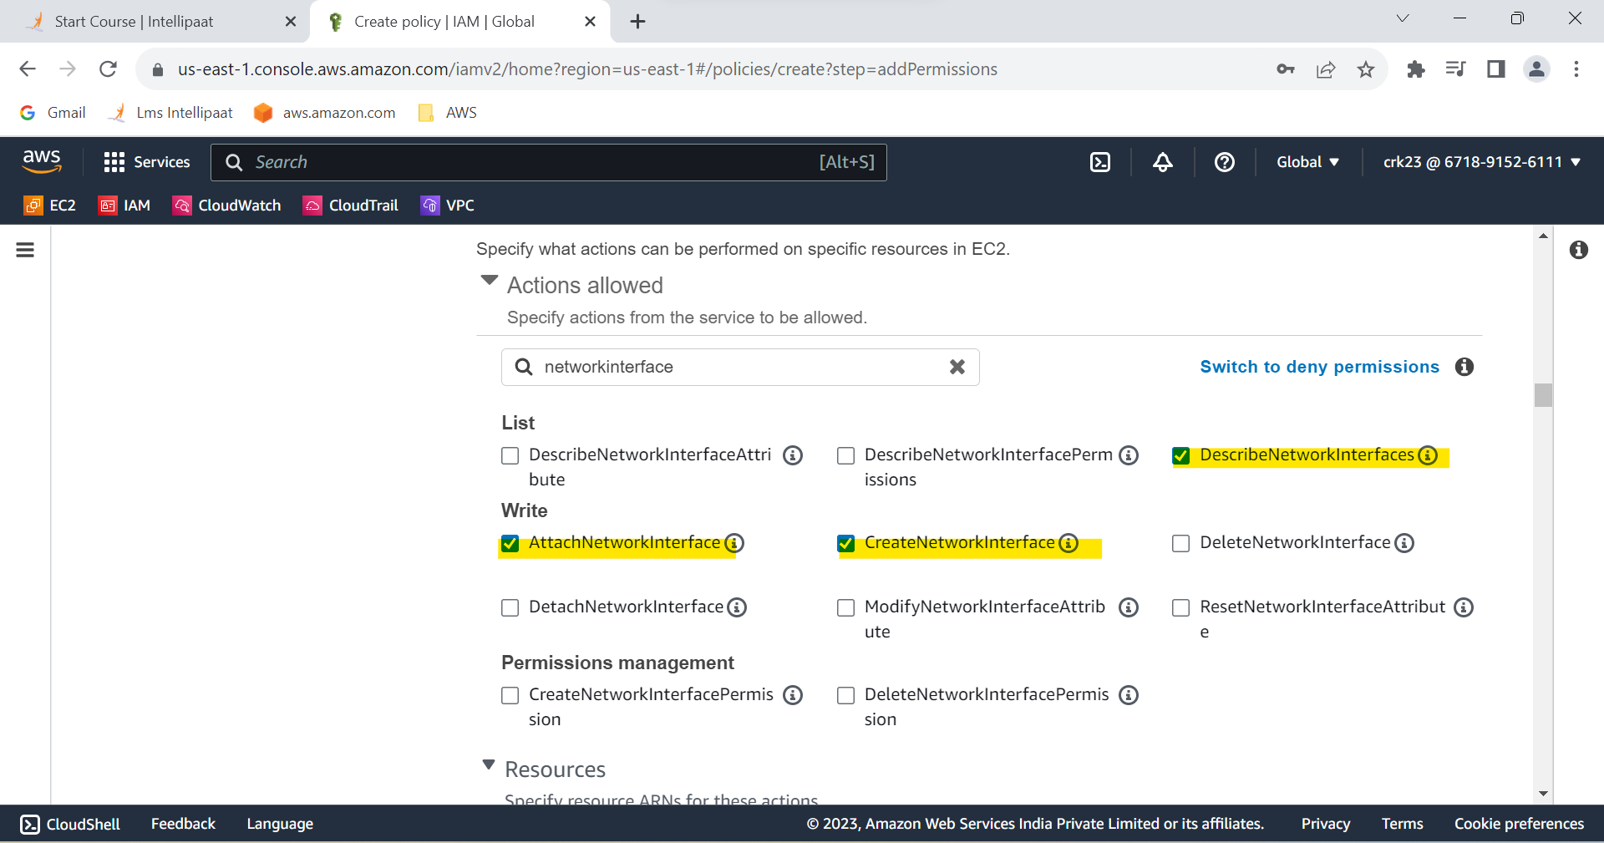

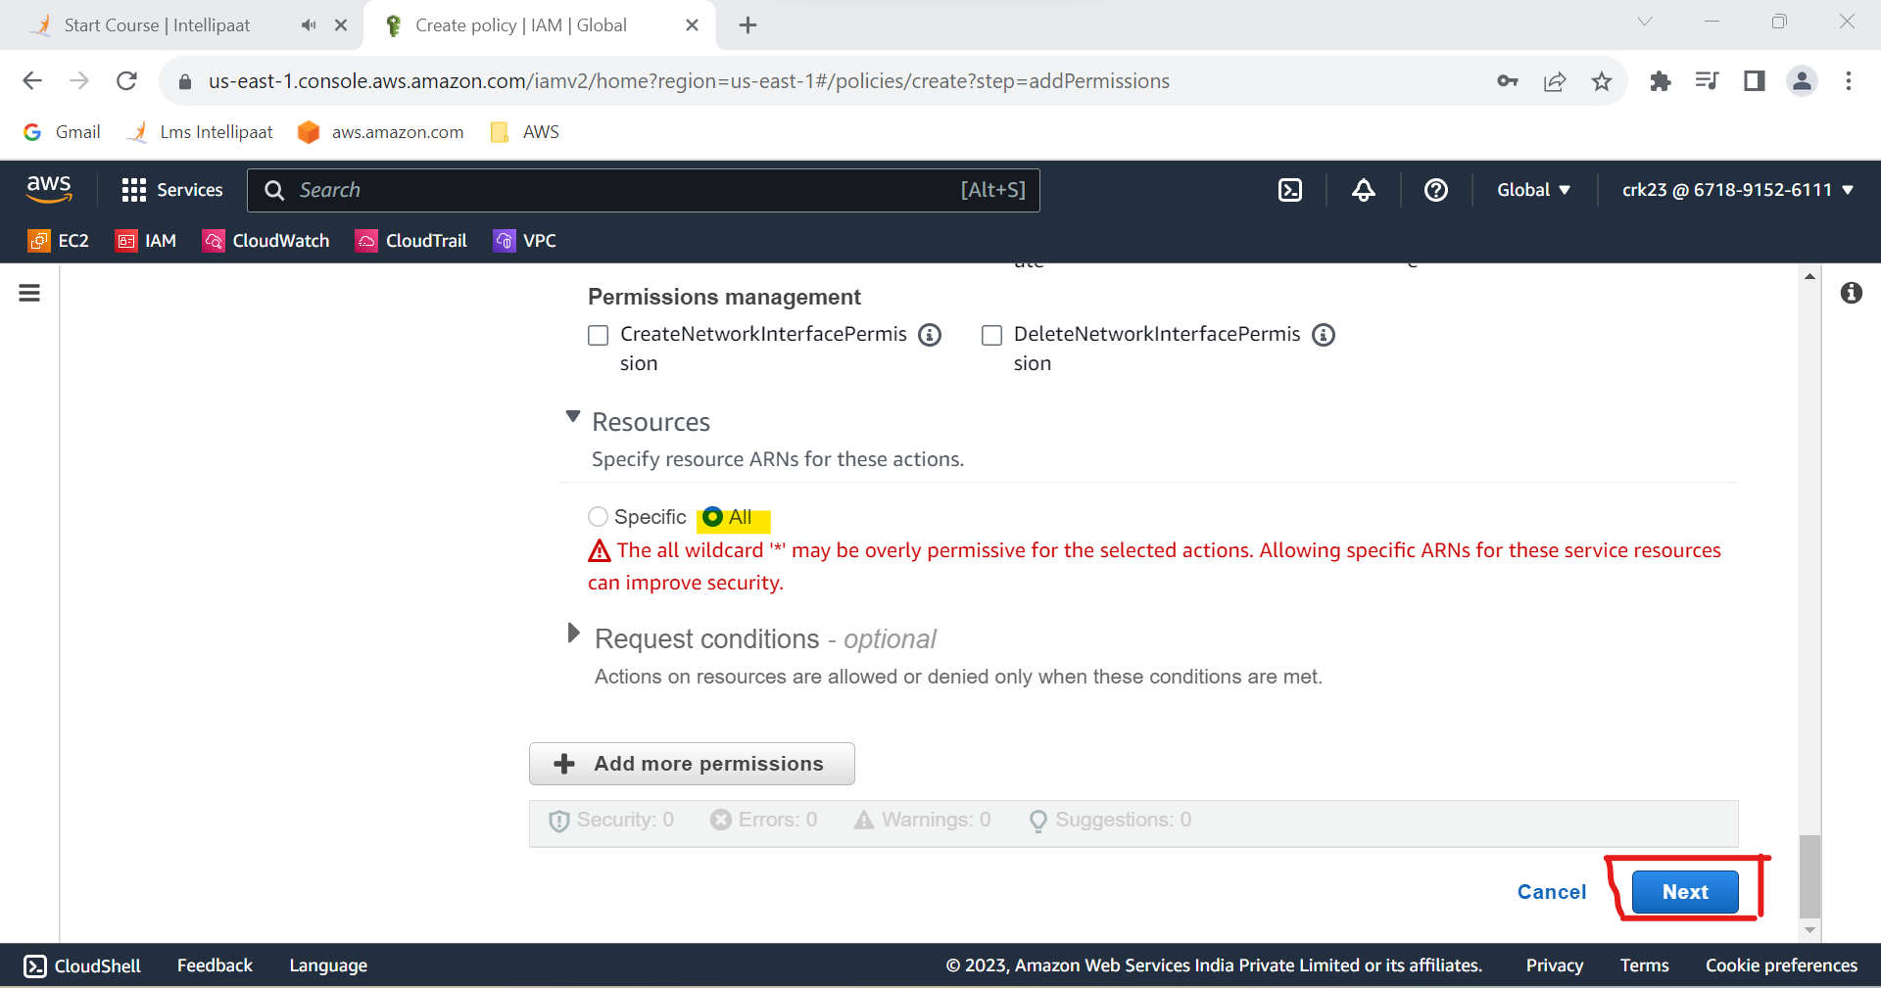

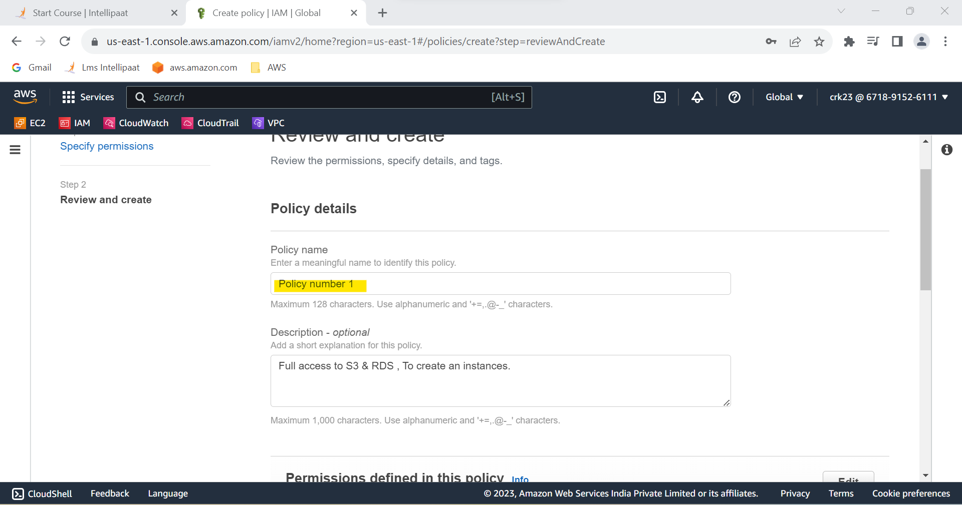

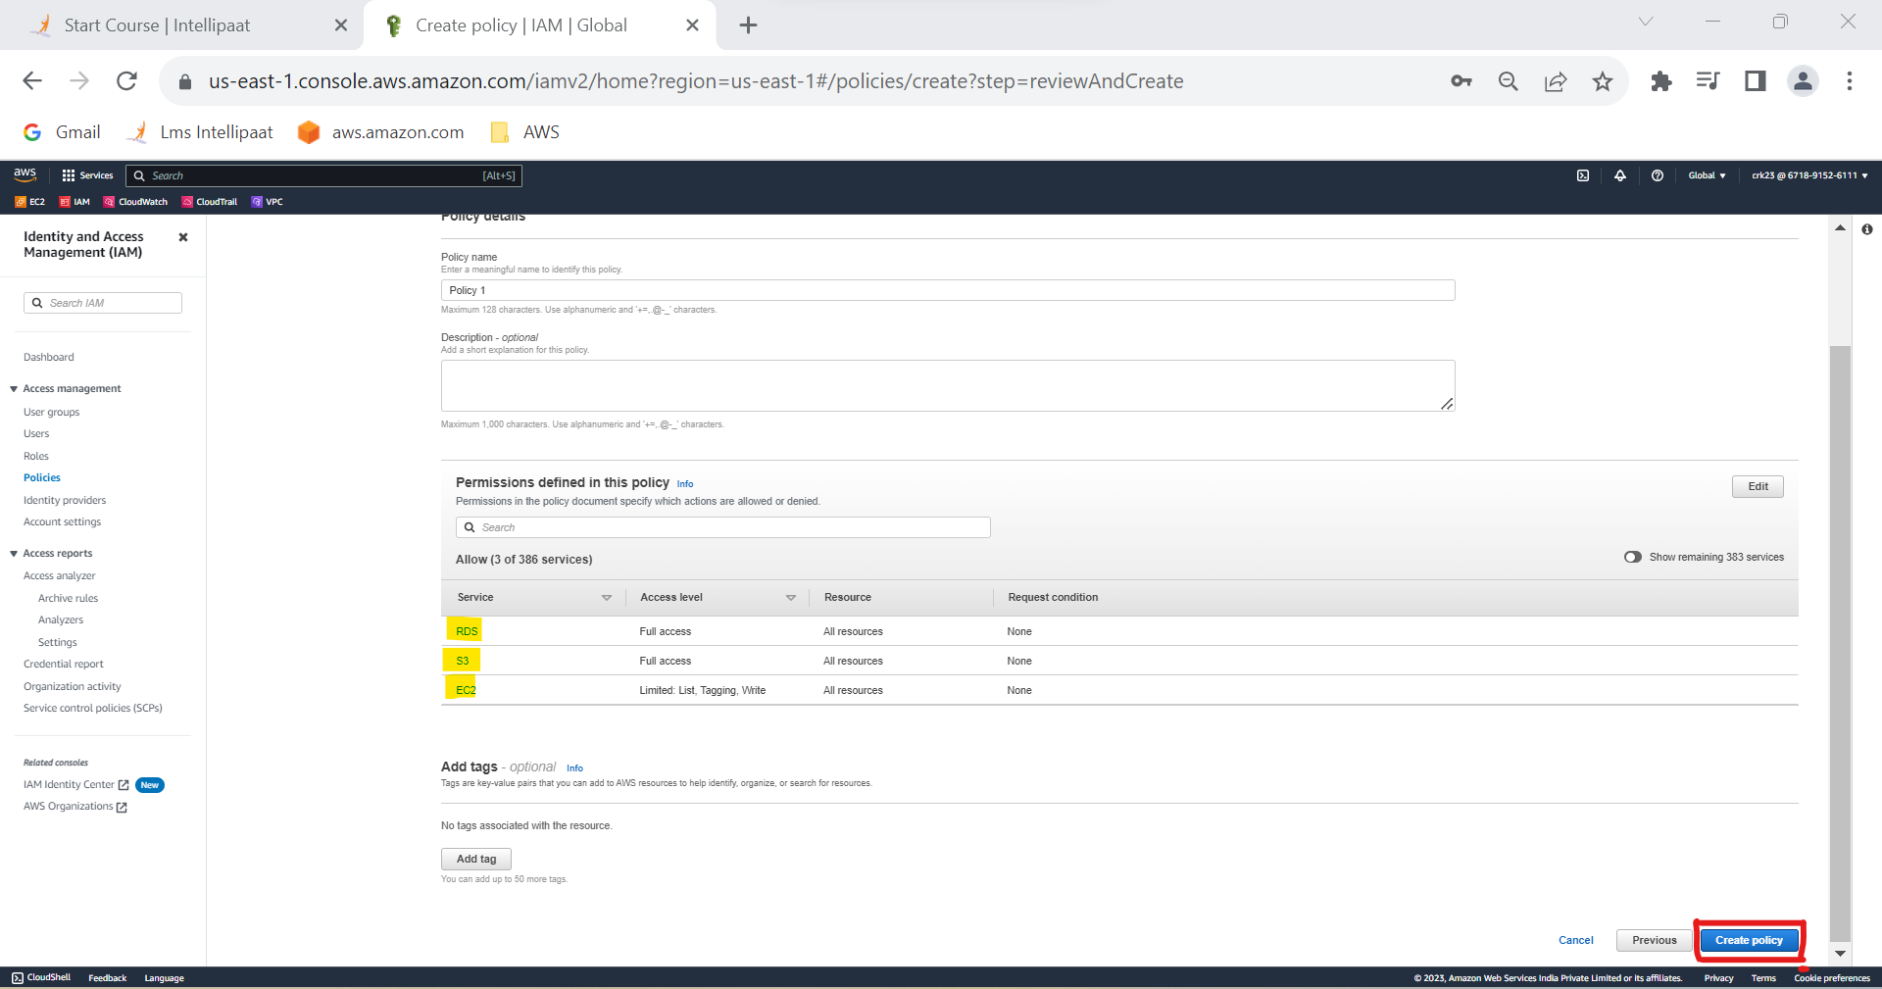

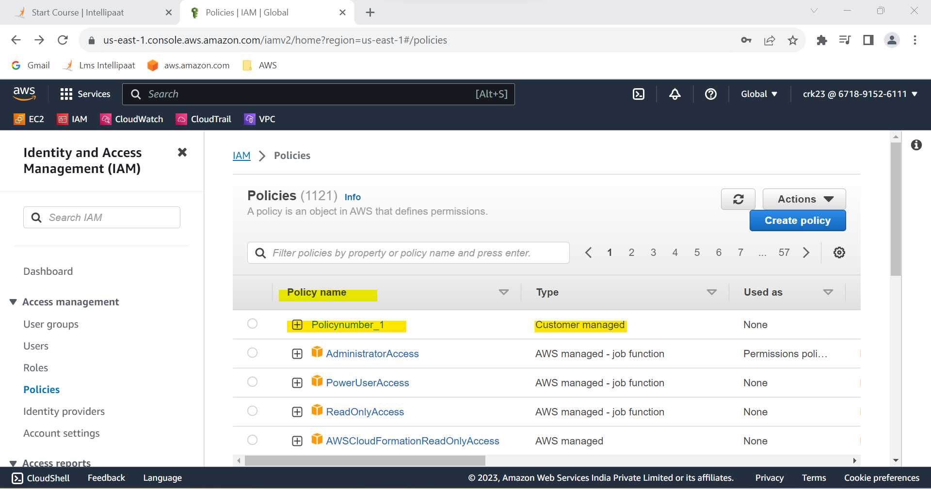

**TASK 1 OUTPUT :**

Created a policy which lets the users to Access S3 completely , Only create EC2 instances , Full access to RDS .

**TASK 2 :**

Create a policy number 2 which allows the users to:

a. Access CloudWatch and billing completely

b. Can only list EC2 and S3 resources

**STEP 1 :** I have repeated the same steps from TASK 1 to Create Policynumber_2

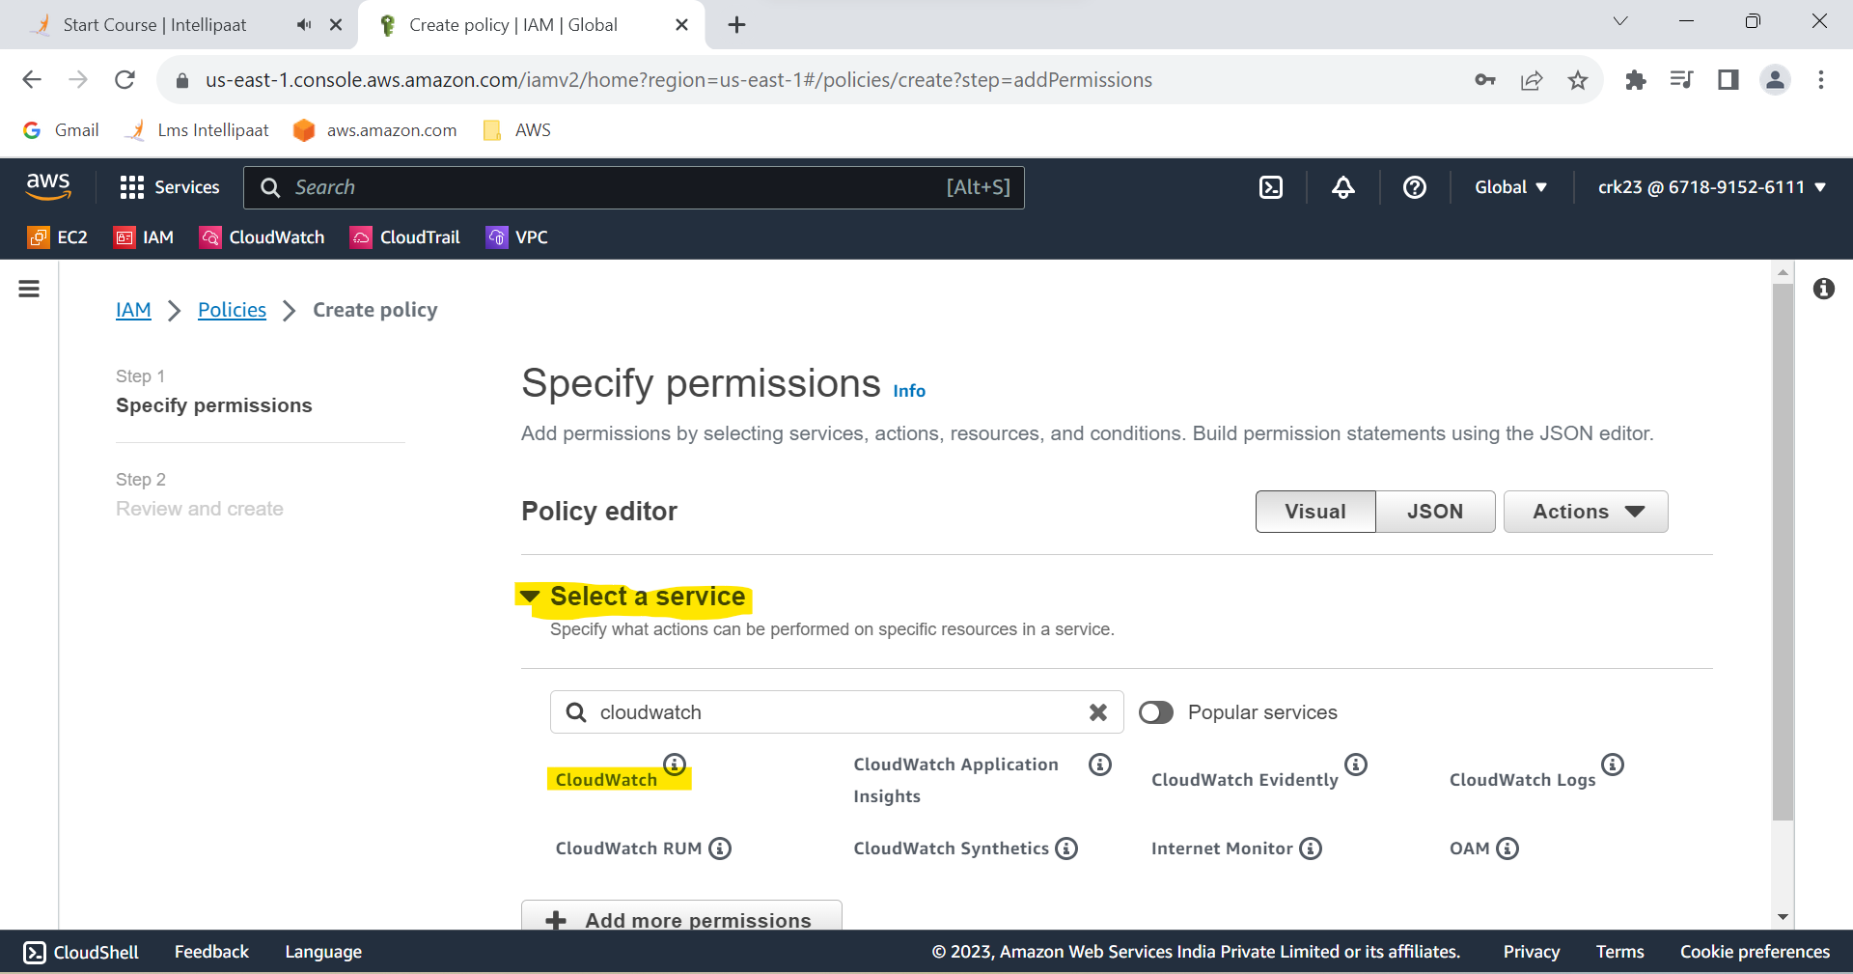

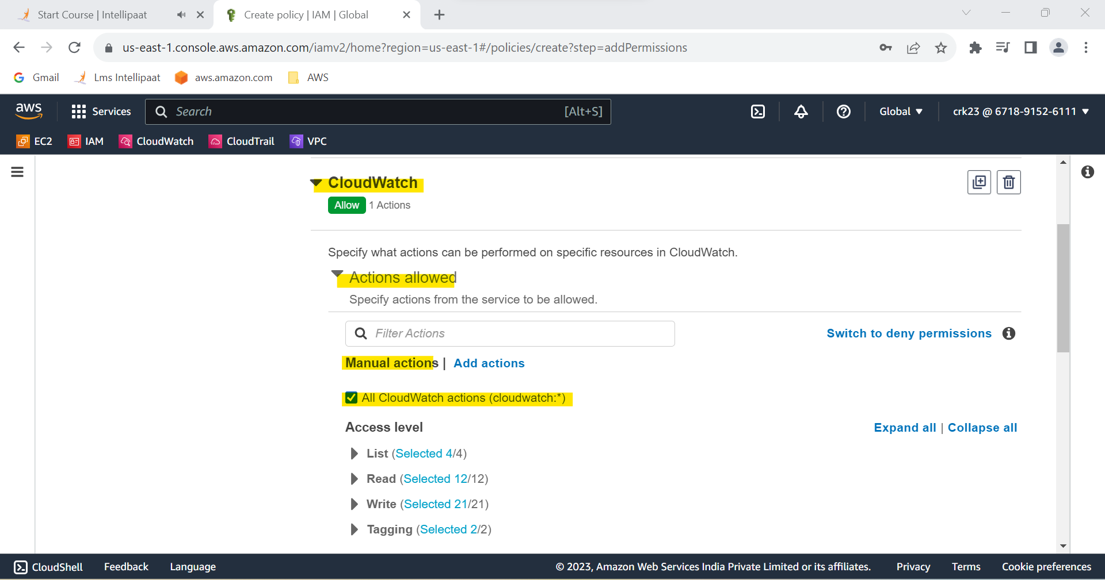

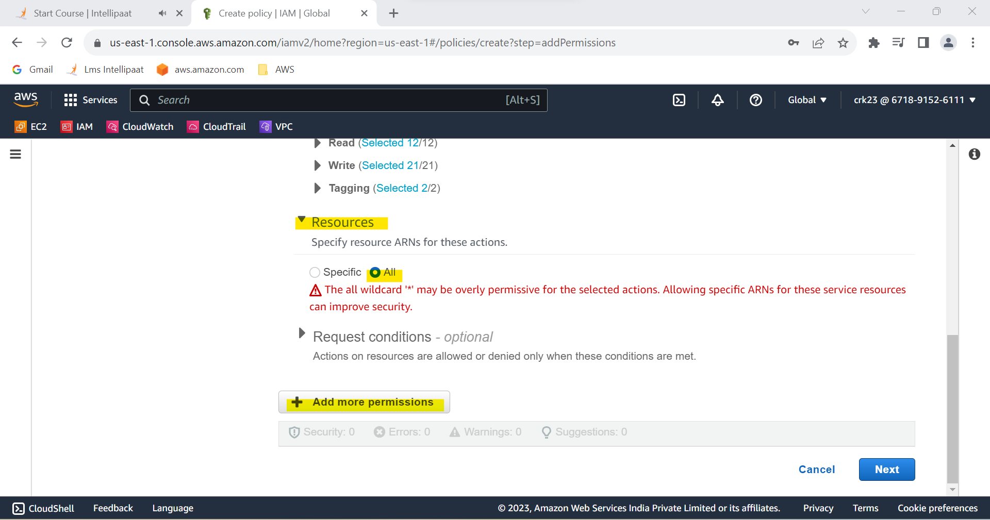

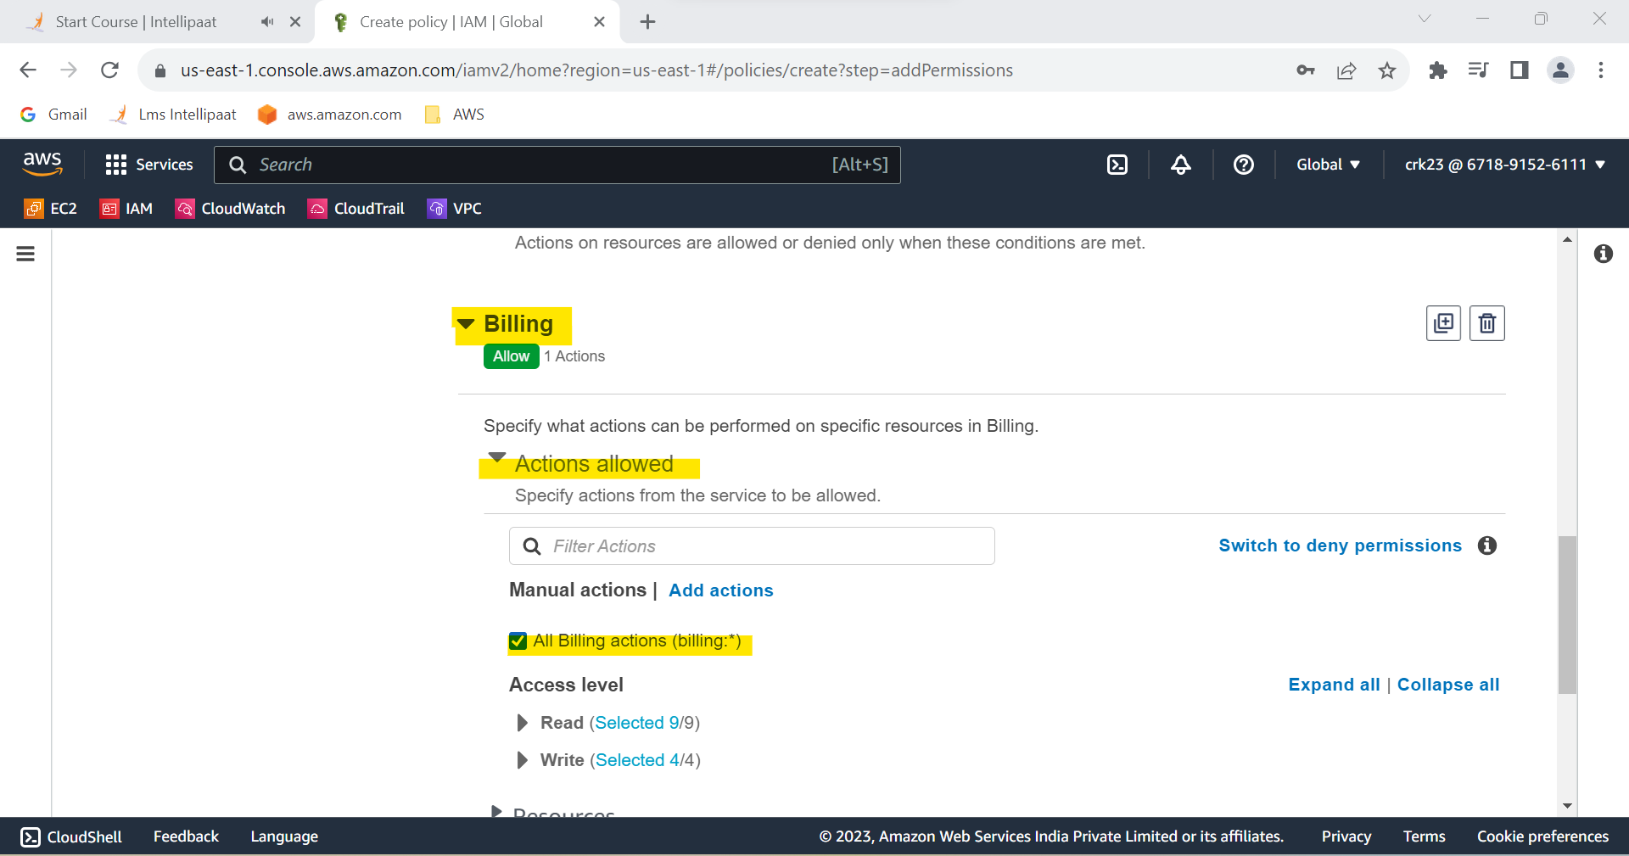

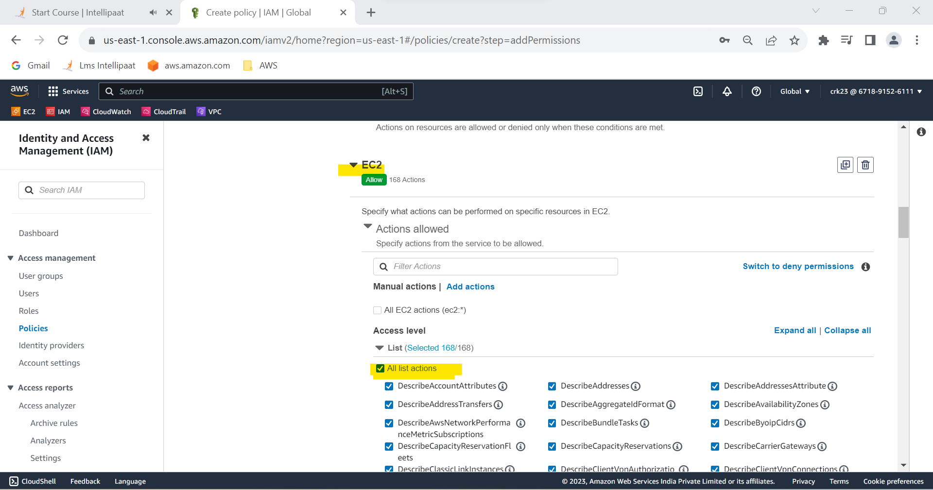

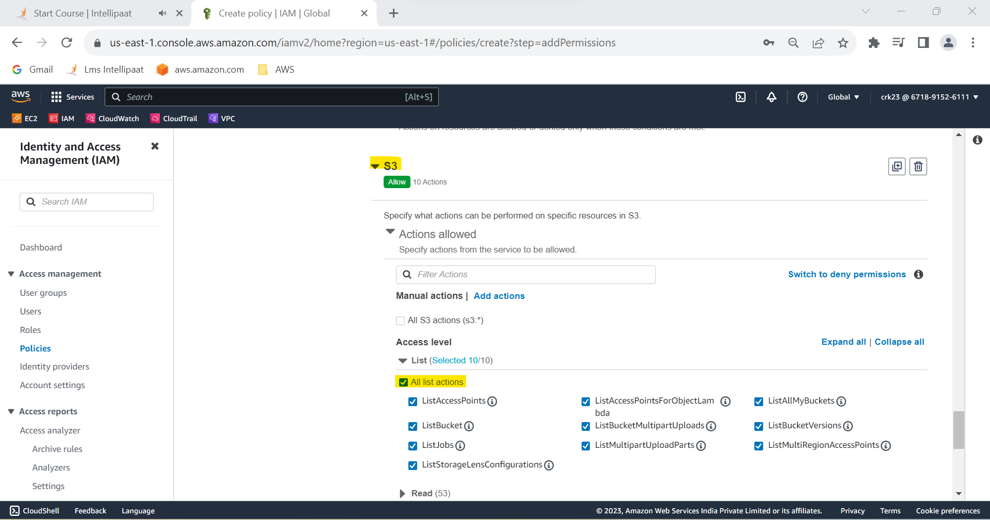

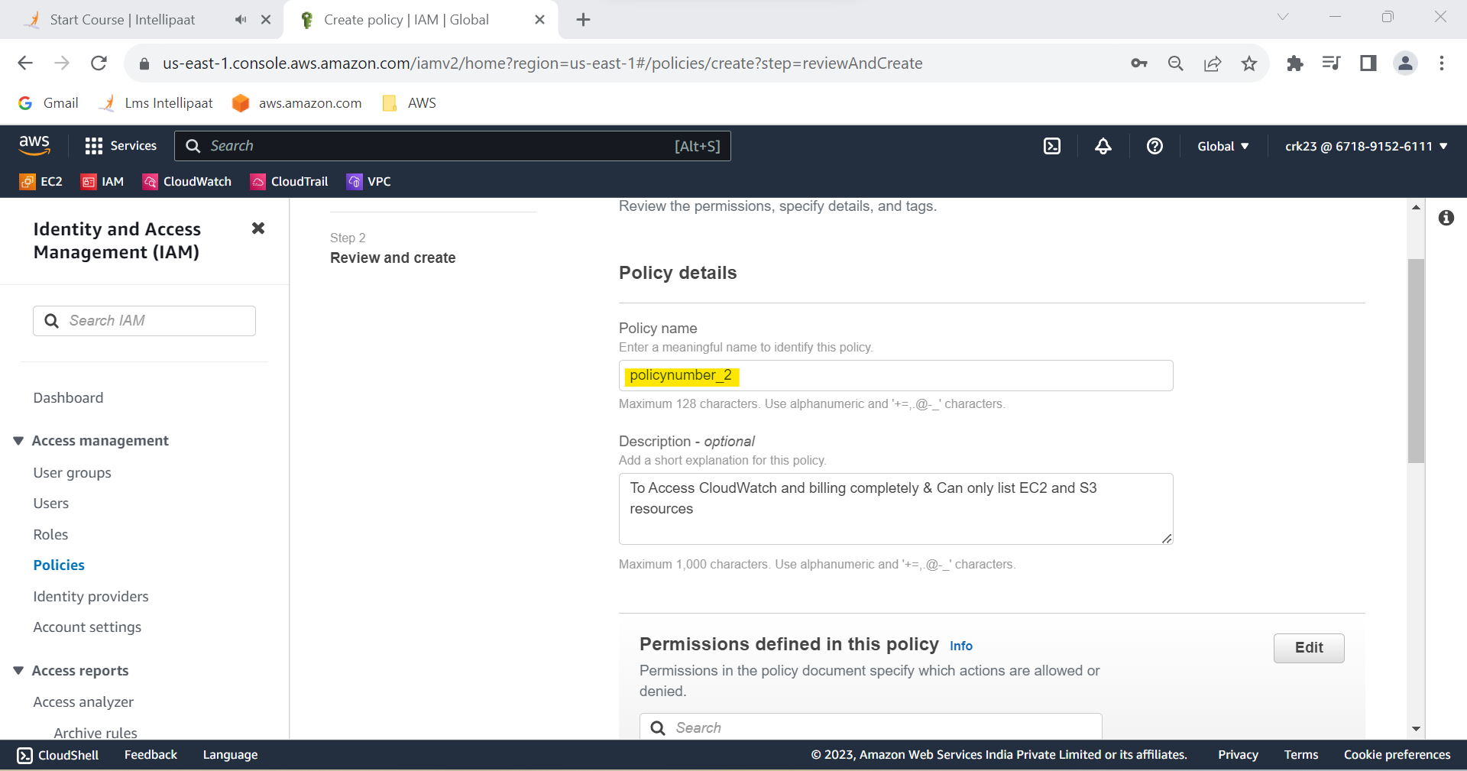

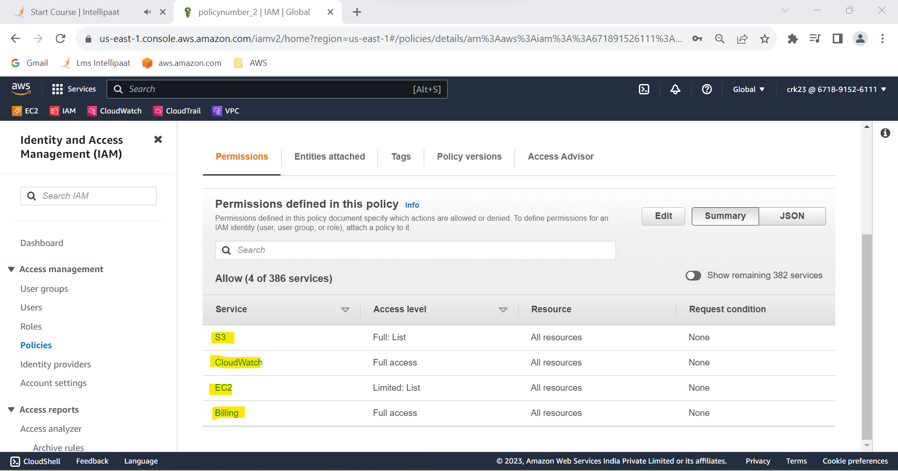

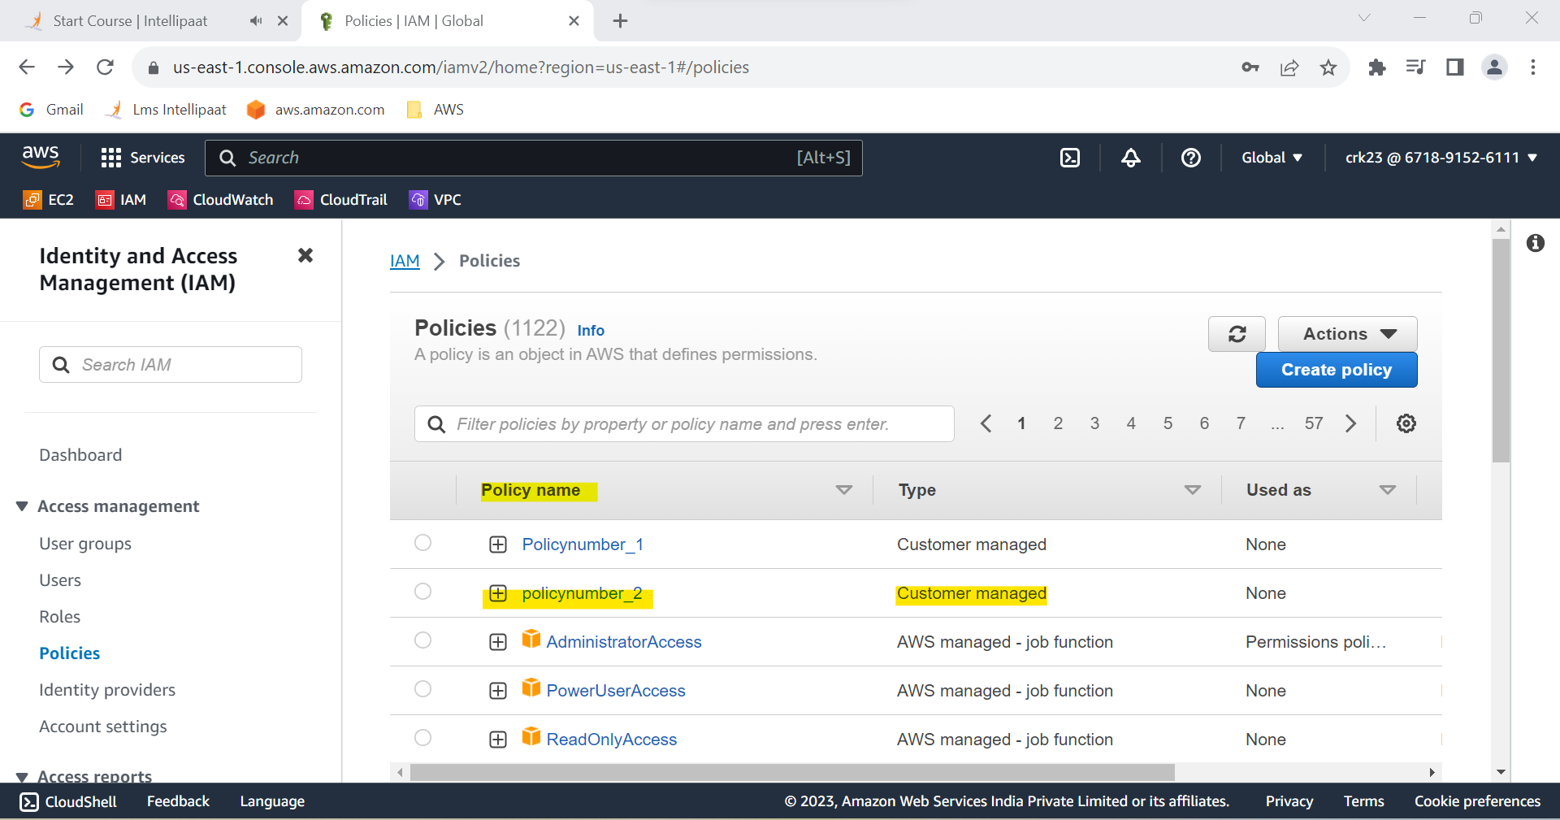

**TASK 2 OUTPUT :**

Created policynumber_2 to Access CloudWatch and billing completely

And Can only list EC2 and S3 resources .

**TASK 3:**

Attach policy number 1 to the Dev Team from task 1

**STEP 1 :** In access management selects user groups

**STEP 2 :** Select the Dev_Team

**STEP 3 :** In the Dev_Team select permissions

**STEP 4 :** Select Add permissions > attach policies

**STEP 5 :** Select Policynumber_1 and select Add permissions

**STEP 6 :** Policynumber_1 added to Dev_Team

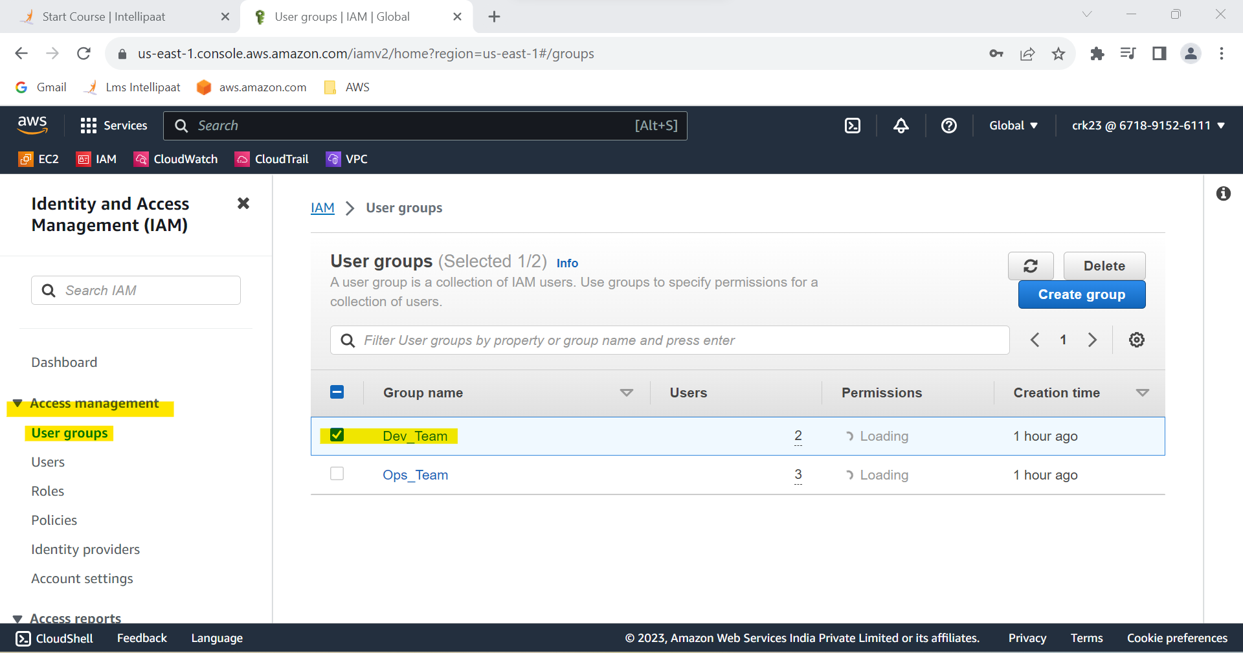

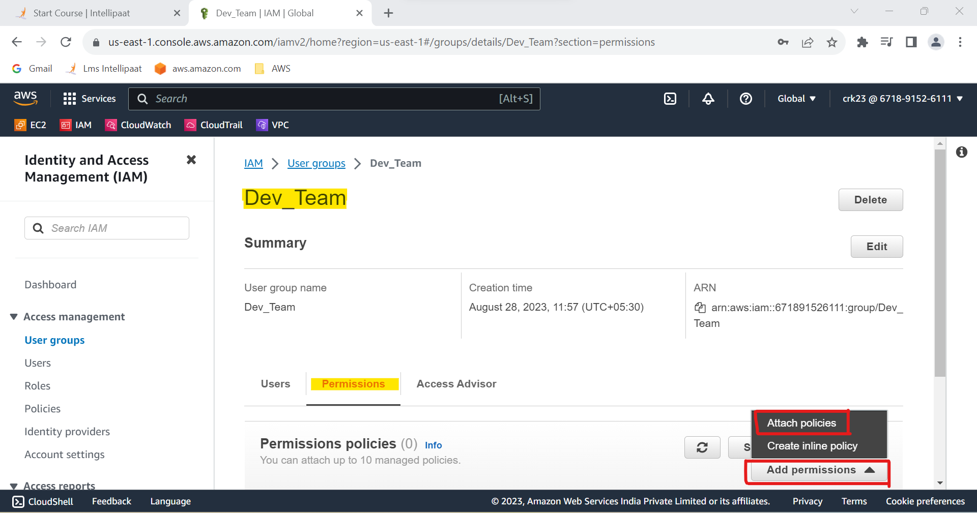

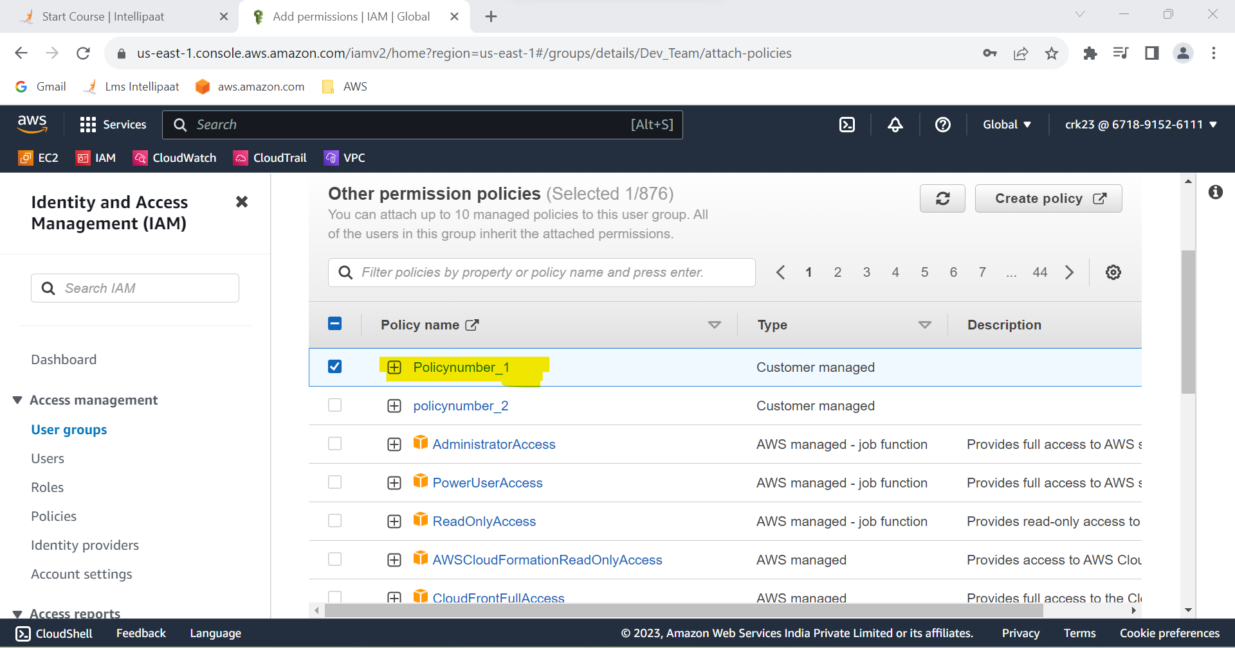

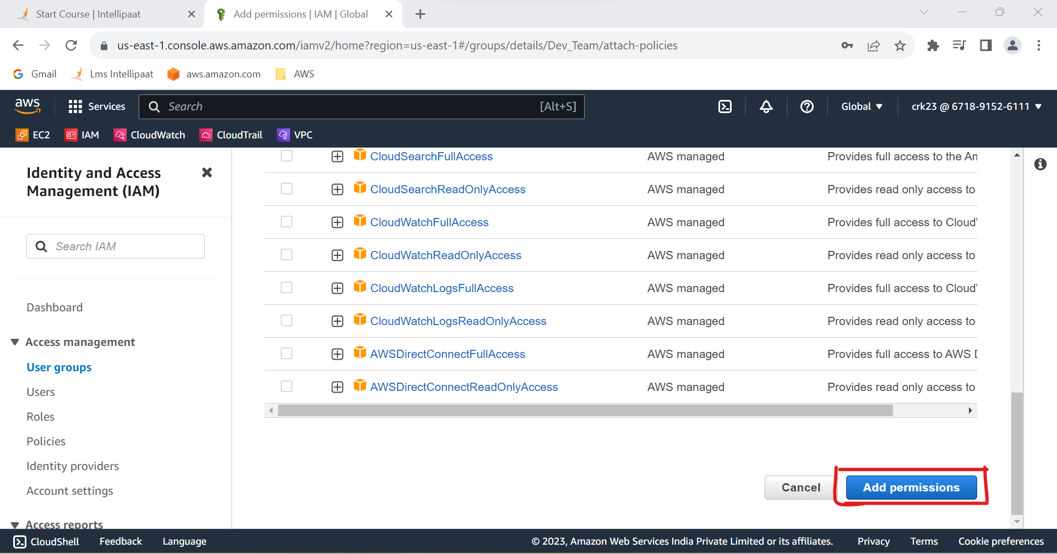

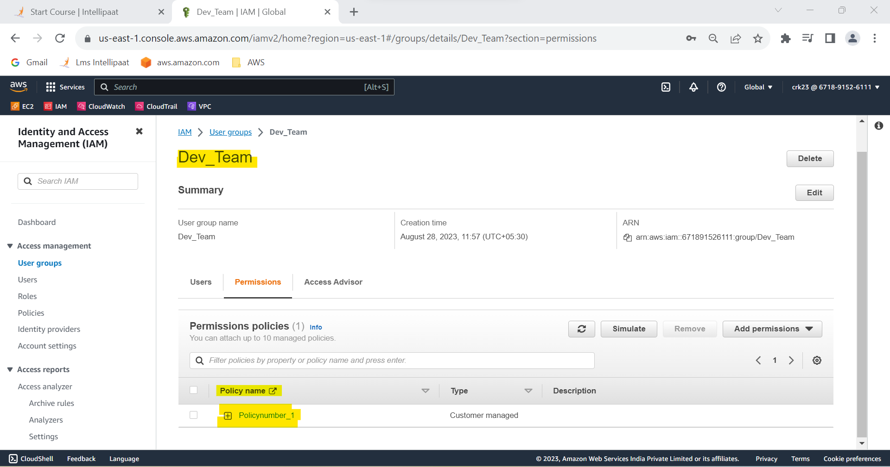

**TASK 3 OUTPUT :**

Attached policynumber_1 to the Dev Team from task 1

**TASK 4 :**

Attach policy number 2 to Ops Team from task 1

**STEP 1:** Same steps from the TASK 3 have been done to add policy 2 to

Ops_Team.

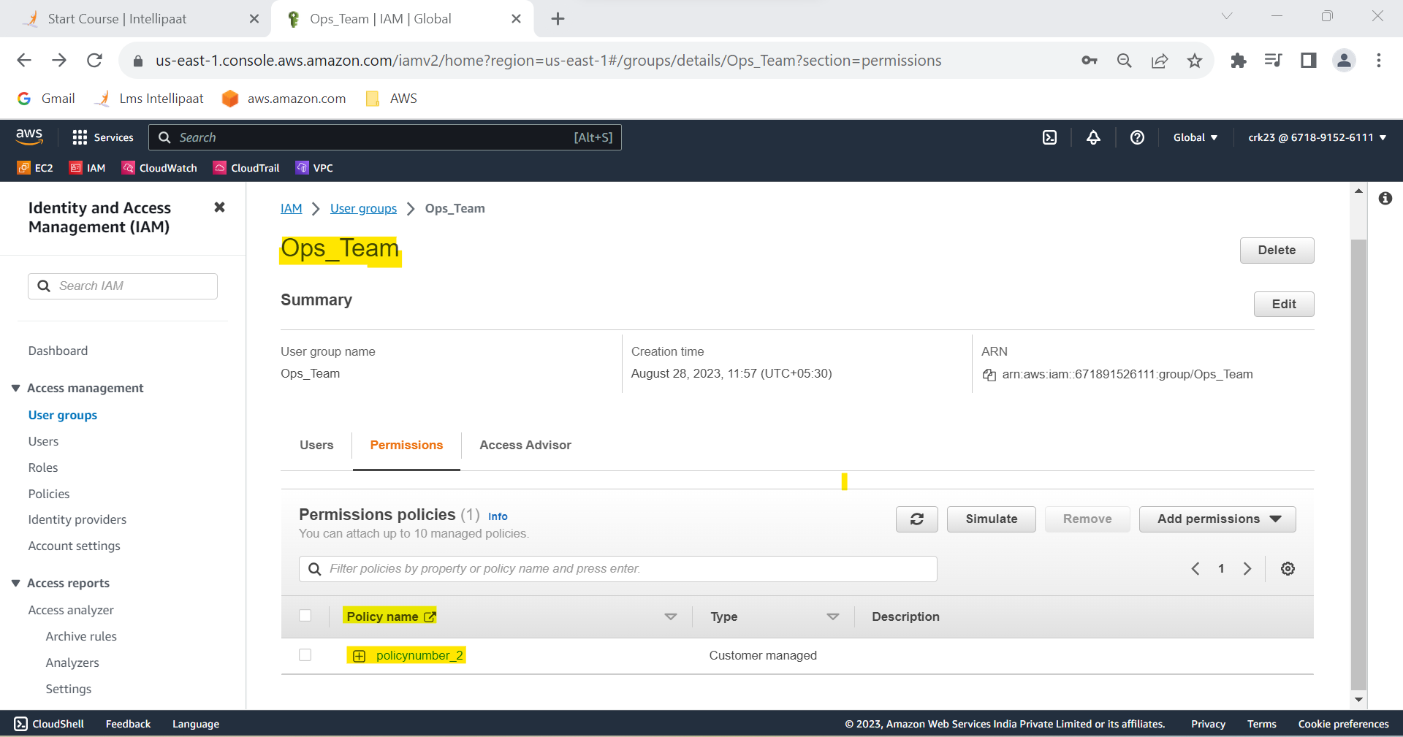

**TASK 4 OUTPUT :**

Attached policynumber_2 to Ops Team from task 1